**KATHMANDU UNIVERSITY**

SCHOOL OF ENGINEERING

**DEPARTMENT OF COMPUTER SCIENCE & ENGINEERING**

**LAB 1**



**“Computer Graphics”**

A **Third year/ Second Semester** System Analysis and Design [COMP 342]

Lab Work submitted in partial fulfillment of the requirements

for the degree of Bachelor of Engineering.

**Submitted by:**

Ashish Pokhrel

Faculty: C.E.

Roll: 38

Registration No: 022446-17

**Submitted to:**

Mr. Dhiraj Shrestha

Department of Computer Science and Engineering

**Aug 2, 2020**

1. **Mention the name of Programming language and Graphics Library you are using this semester for performing your Computer Graphics Lab and Project.**

I will be using following programming language and Graphics library for all Graphics lab in this semester:

**Programming language:** JavaScript

**Graphics Library:** p5.js

1. **Write the code snippets for setting graphics environment in your chosen graphics library and display the resolution of your display system through functions/classes provided by your graphics library.**

For setting environment of p5.js code snippets is not necessary. You can directly start to code from the online editor <https://editor.p5js.org/>

But to run it locally we need to download the source file from <https://p5js.org/> and can code in sketch.js. We would require any live server extension for visual studio code IDE to code in it locally.

Code snippets for displaying the resolution of my system is given below:

**Code Snippet:**

function setup() {

console.log( displayWidth, displayHeight);

 }

  // Display system Display Resolution

**Output:**

1536 864

The Display Resolution of my system is 1536*864. i.e, Height is 1536 and Width is 864.

1. **Get Familiar with the coordinate system and Draw a flag of Nepal using the chosen Graphics geometrical functions/ classes provided by your chosen graphics library and also color the flag accordingly.**

I will be using **700 * 550** sized Canvas.

**Source Code:**

function setup() {

  createCanvas(700, 550);

  // Creates canvas for drawing

  noStroke();

  // Removing the black portion of shapes

}

function draw() {

  background("#9b59b6");

  // Outline of flag

  fill(18,30,140);  //Filling the outer shape first with blue color

  beginShape();

  vertex(100,100);

  vertex(400,300);

  vertex(200,300);

  vertex(400,500);

  vertex(100,500);

  endShape();

  // Outer Shape Completed

  //For red part inside of the blue

  fill(205,20,10);

  beginShape();

  vertex(115,125);

  vertex(360,290);

  vertex(170,290);

  vertex(370,490);

  vertex(110,490);

  endShape();

  // completed drawing the  red part

  //Drawing moon with white circle stacked with red circle

  fill(255,255,255);

  // crescent shape of moon

  ellipse(172,242,60,60);

  fill(206,24,13);

  ellipse(172,227,60,60);

  // Used Triangles for moon

  fill(255,255,255);

  ellipse(172,255,30,30);

  triangle(172,240,179,247,177,234);

  triangle(172,240,165,247,166,234);

  triangle(177,242,182,248,184,236);

  triangle(167,242,160,248,161,236);

  triangle(182,244,187,252,188,240);

  triangle(162,244,158,252,156,238);

  triangle(180,252,190,256,193,243);

  triangle(164,252,155,256,151,243);

  // Completed making moon

  // Drawing of SUN

  ellipse(172,400,44,44);

  let v0 = createVector(172, 400);

  let v1 = createVector(33, 0);

  for(var ang=0;ang<360;ang += 30){

    ToDrawSun (v0, v1.rotate(ang), 'white',ang);

  }

}

function ToDrawSun (base, vec, color,radian) {

  push();

  fill(color);

  translate(base.x, base.y);

  rotate(radians(radian));

  translate(vec.mag() - 14, 0);

  triangle(0, 7, 0, -7, 14, 0);

  pop();

}

**Output:**

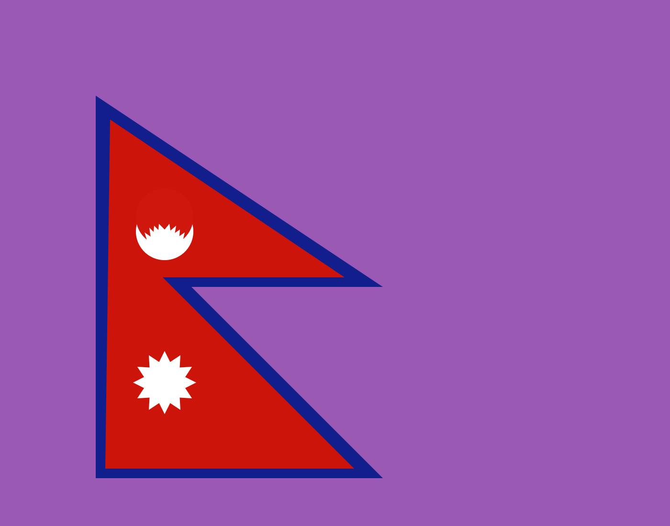

*Fig: Flag of Nepal*

**Conclusion:**

Hence with the help of P5.js library National Flag of Nepal was made. We learned about various functions used in P5.js library in this project.